Answer Keys to Homework Problems
HW1:
Problem 1: a) -0.10384 C b) -0.19865 C c) -3.941 C d) -26.08 C
Problem 2: 25 C Problem3: q = 3,672 C E = 4406.4 J
Problem 4: a) 1.4725 C b) -90e^{-4t} c) -22.5 J
Problem 5: 3A Problem 6: $1.35 Problem 7: 24 cents
HW2:
Problem 1: a) 6 branches and 5 nodes. b) 7 branches and 5 nodes.
Problem 2: i₁ = 14 A i₂ = -2 A i₃ = 10 A
Problem 3: v1 = 6 v2 = 3 V Problem 4: v1 = 2 V v2 = -22 V v3 = 10 V
Problem 5: vx = 4.167 V Problem 6: v₀ = 8 V and I₀ = 0.2A
Problem 7: R_{eq} = 727.3 R_{eq} = 3 K Problem 8: R1 and R3
Problem 9: R1 = 3000 R2 = ∞
HW3:
Problem 1: v₁ = 0 V, v₂ = 24 V Problem 2: v₀ = 20 V Problem 3: i0 = 1.73 A
Problem 4: V1 = 10 V V2 = 4.933 V V3 = 12.267 V
Problem 5: RL = 9 Problem 6: I1 = 0.8 I2 = -0.9
Problem 7: I0 = -1.7333 A Problem 8: i₀/i_{s} = –0.3

Problem 9: Problem 10: v₀/v_{s} = –8
HW4:
Problem 1: v_{o} = 4.5V Problem 2: i = 1.875 A p = 10.55 watts
Problem 3: v_{x} = –26.67V Problem 4: I = 3A P= 72W Problem 5: v_{o} = 3 V
Problem 6: v_{o} = –125 mV Problem 7: R_{th} = 20 V_{th} = -16.4 V
Problem 8: R_{n} = 3 I_{n} = 1A Problem 9: R = 25 P = 7.84W
Problem 10: a) R_{s} = 8 k ohms, I_{s} = 10 mA b) im = 9.926 mA
HW5:
Problem 1: a) vo = 2V b) vo = 3v
Problem 2: vo = 2.7V io = 288 uA
Problem 3: io = 0.375 mA
Problem 4: vo = 1.8
Problem 5: P = 108 mW ix= -6mA
Problem 6: Rf = 10k R1=R2=R3=R4 = 40k
Problem 7: vo = 14.09V
Problem 8: 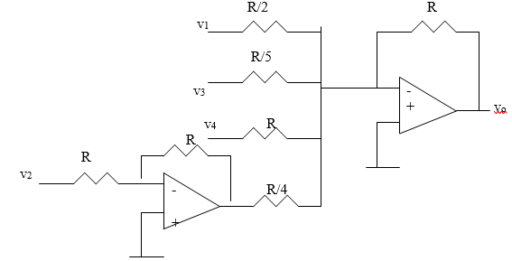
Problem 9: io = 1.3695 mA
Problem 10: io/is = 9
HW6:
Problem 1: v(2) = 13.624 p(2) = 70.66W
Problem 2: v1 = 30V v2=40V
Problem 3: a) v1(t) = -1250e^{-2t} + 1300V v2(t) = -250e^{-2t} + 270V
b) w_{12uF} = 4.235J w_{20uF} = 0.3169J w_{40uF} = 0.6339J
Problem 4: a) Leq = 6.667 mH i1(t) = e-t mA i2 = 2e-t mA
b) vo= -20e-t uV c) w = 1.353 nJ
Problem 5: a) w5 = 40 J w20 = 40 J b) W = 80J
c) i1 = 5x10⁻⁵(e^{-200t} – 1) + 4 A i2 =1.25x10⁻⁵ (e^{-200t} – 1) – 2 A
d) i = 6.25x10⁻⁵ (e^{-200t}– 1) + 2 A
Problem 6: vo = -30 mV
Problem 7
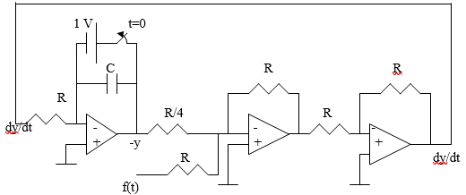
HW7:
Problem 1:a) R=7 K, C = 0.7143 uF b) taw = 5 ms c) to = 3.466 ms
Problem 2: v = 40 e^{-50t} V
Problem 3: v_{o}(t) = 4e^{-5t} V for all t > 0
Problem 4: i_{o}(t) = 1.41e^{-3t} A
Problem 5: i(t) = 2e^{-5t} u(t) A
Problem 6: a) v(t) = 4 for t<0 and v(t) = 20 -16e^{-t/8} for t> 0 b) v(t) = 4 V for t<0 and 12-8e^{-t/6} for t>0
Problem 7: i(t) = 0.8 A for t<0 and i(t) = 0.8e^{-t/480} A for t>0
Problem 8: v(t)= 96 V for t<0 and v(t) = 96e^{-4t} u(t) V
Problem 9: i_{o}(t) = - 50 u(t) mA
Problem 10: Speed = 6.278 m/s

HW9:
Problem1: (a) V_{m} = 50 V. (b) Period = 209.4ms (c ) Frequency f = 4.775 H_{z}. (d) v(0.01) = 44.48 V
Problem2: the phase angle between the two signals is 20 and v₁ lags v₂.
Problem3: a) 50.88∠–15.52˚. b) 60.02∠–110.96˚.
Problem4: (a) V = 21∠-15º V (b) I = 8∠160º mA (c ) V = 120∠-140º V (d) I = 60∠190º mA
Problem5: (a) -1.2749 + j0.152 (b) –2.083 (c) 35 +j14
Problem6:
Problem7: 1.414 sin(200t – 45) V
Problem8: 6.83 + j1.094 = 6.9179.1 I = 17.350.9 A
Problem9: Proof
Problem10: C = 235 pF
HW10:
Problem1: i(t) = 1.9704cos(10t+5.65˚) A
Problem2: V = 124.08∠-154º V
Problem3: 2.828 cos(2t + 45) A
Problem4: i₁(t) = 2.741cos(4t–41.07˚)A, i₂(t) = 4.114cos(4t+92˚)A.
Problem5: i_{o}(t) = 8 +1.5811 cos(4t – 71.57) A
Problem6: i(t) = [989.1cos(10t+21.47º) + 499sin(4t+176.57º)] mA
Problem7: i(t) = 8.944 sin(200t + 56.56) A
Problem8: a) Zn = Z_{th} = 22.36-63.43 V_{th} = -5030 V I_{n} = 2.236273.4 A
b) Z_{n} = Z_{th} = 1026 V_{th} = 33.9258 V I_{n} = 3.39232 A
Problem9: 89.45 cos(10⁴ t +3.44) A
Problem10: 3.578 cos(1000t + 26.56) V

